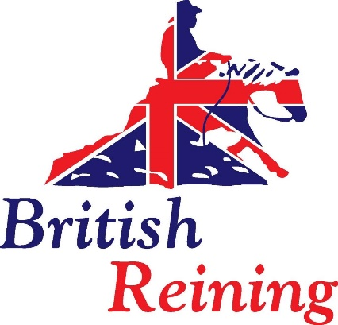
Level 1, Level 2 and Level 3 British Reining Western Coaching Certificate (endorsed by UKCC)
Application Form

PLEASE COMPLETE IN BLOCK CAPITALS
Personal Details
Full Name
Address

Telephone Number
Email Address
Date of Birth
Membership Number
Level you are applying for | Level 1 ⃝
 | Level 2 ⃝
 | Level 3 ⃝
Do you have any disability, learning need or anything else that may affect your ability to cope with the qualification which would result in a reasonable adjustment being required? If yes, please provide details.

Qualifications and experience
Please use this space to list your current equestrian qualifications, (for example British Reining UKCC/ Pony Club Tests/BHS stages) and the year in which they were achieved if known. (Please use overleaf if extra space needed)

Please use this space to outline any courses you have completed both equestrian/ non-equestrian that you think are relevant. Please think about the outcomes and objectives of the course you attended which will provide useful information in support of your application. (Please use overleaf if extra space needed)

Please outline your stable management and horse care experience. The level 2 and level 3 Coaching Certificate require you to demonstrate a competent level of horse care. If you can, give evidence of:
Any relevant horse care qualifications if not already listed (eg. BHS/Pony Club/ABRS/Diploma/Certificate) and/or experience of horse care and stable management of horses (please give period of time, number of horses in your charge, responsibilities e.g. care and feeding, work rota’s tack fitting etc.) Please use overleaf if extra space needed

Please detail below any coaching/teaching experience including details of how many riders you have coached, what level, ability and age of riders, any clinics you have coached and at what venues. (Please use overleaf if extra space needed)

*Level 3 candidates only
Please indicate below two riders you could use for your portfolio that you are currently coaching on a regular basis and the level in which they are competing at.

Rider one | Rider Two
Name | Name | Name
Level working at | Level working at

References –
Please ensure that you are not related to the referee. Ideally one should be from someone who has observed you coach or that you have regularly coached.

** If you are applying for a Level 1 qualification, one referee MUST be a coach who can confirm your technical competence in relation to the Level 1 Technical Syllabus, eg BR UKCC Level 3/4 coach

*** If you are applying for direct entry at Level 2, one referee MUST be a coach who can confirm your technical competence in relation to the Level 2 Technical Syllabus and your current coaching status, eg BR UKCC Level 3/4 coach

Referee 1 | Referee 2
Name | Name
Address | Address
Telephone Number | Telephone Number
Email | Email
How is your referee known to you? | How is your referee known to you?
How long have you known your referee? | How long have you known your referee?
Referee Signature | Referee Signature
Date | Date

Your references may be contacted to verify that the information you have provided on this form is accurate and can be attributed to you.

Bookings and Payment

Registration and Assessment fees must be paid to British Reining prior to booking on a workshop

Registration and Assessment 2020 prices

Level 1 - £300
Level 2 - £320
Level 3 - £350

Full membership of British Reining is required for all levels.

Workshops and Course Materials

Level 1 – (2-day workshop) £250
Level 2 – (2 x 2-day workshops) 2 x £250 = £500 total
Level 3 – (4 x 2-day workshops) 4 x £250 = £1,000 total

Each 2-day workshop must be booked and paid for at least 2 weeks in advance of the workshop date. Payment for the workshops to Pauline Brimson via BACS or cheque.

I can confirm that the information given by me on this form is correct to the best of my knowledge and that I am happy for my information to be passed to the Coach Educator/Assessor delivering the course/Assessment.

Signed: Date:

Pre-requisites

Prior to coming forward for Assessment you must have the following completed and available for examination by the Assessor:

- Completed portfolio which has been signed off by the Coach Educator or Assessor
- Evidence of third-party liability insurance (or employers’ insurance details) This must be valid for a minimum of 3 months
- First Aid at Work certificate (one-day certificate acceptable for Level 1 ONLY). This must be valid for a minimum of 3 months.
- DBS certificate (Not required for Level 1)
- Safeguarding and Equity certificate (Not required for Level 1)

Failure to provide these documents may result in you being unable to proceed with your practical assessment.

